I Spy



In this project you will make an AI-powered “I Spy” game.

You will use a pre-trained machine learning model to recognise objects in a picture. The game will be for you to try and guess what the computer has recognised.

Creative Commons LicenceThis project worksheet is licensed under a Creative Commons Attribution Non-Commercial Share-Alike License

http://creativecommons.org/licenses/by-nc-sa/4.0/

1. Go to [https://machinelearningforkids.co.uk/pretrained/](https://machinelearningforkids.co.uk/)   
   *This page displays some pretrained machine learning models that are available to you. For this project, we’ll use the “****Imagenet****” model.*
2. Click on “**Get started**”
3. Click on “**Project templates**”

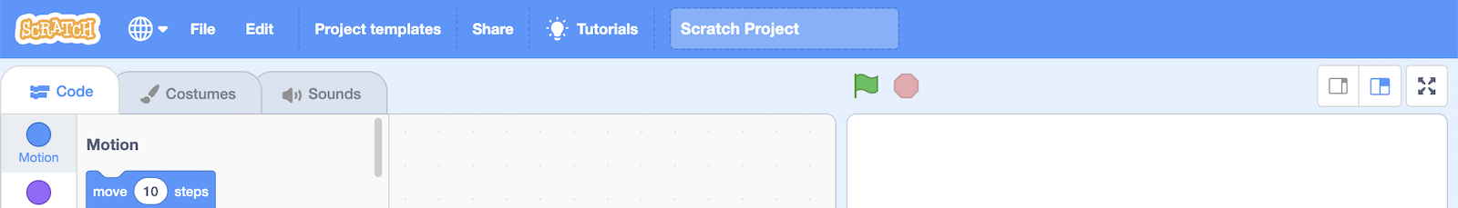

1. Click on the “**I Spy**” template
2. Open the **Extensions** window  
   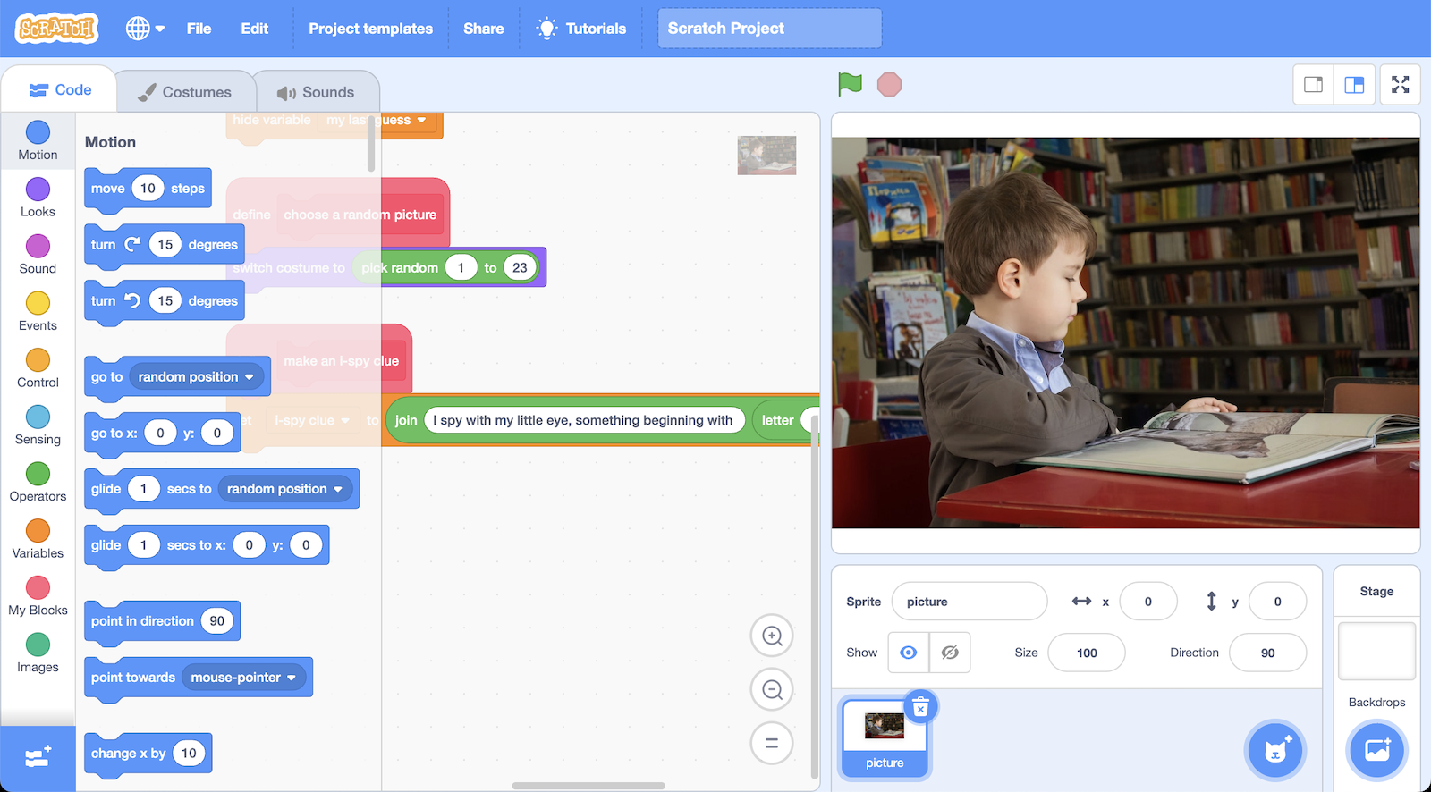
3. Click on the **Imagenet** extension *This adds a new “recognise image” block to Scratch. It will use the imagenet machine learning model to recognise something in the picture that you give to it. You will use this block in Step 7.  
   Graphical user interface, text, application, chat or text message

   Description automatically generated*
4. Click on the “**picture**” sprite   
   
5. Create this code to make the “I Spy” game.   
   *Try to read through it first. Can you understand what it does?*   
   *Text, chat or text message, timeline

   Description automatically generated*
6. It’s time to play! Click on the **Green Flag**.   
   *How many guesses did it take you to guess what the machine learning model had recognised?*
7. Find the code for the “**make an i-spy clue**” custom block  
   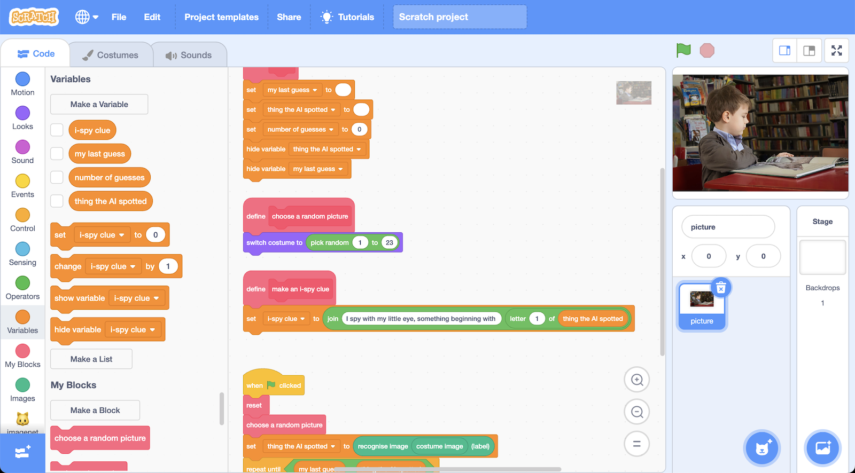

1. Make the game a little easier by making the clue more helpful  
   *This picture shows one way you could do this.   
   If the player has got it wrong three times, it gives the first two letters.   
   If the player keeps getting it wrong, the clue gives the first three letters.  
   You don’t have to use this idea. Make your own clue that you think will make the game easier.*   
   Graphical user interface

   Description automatically generated
2. Click on the **Green Flag** to test again  
   *Did your updated clue help? Try playing with a few of the test pictures.*
3. Go back to <https://machinelearningforkids.co.uk/pretrained>   
   *Read about the Imagenet model, and how it was created*
4. Find your own picture to test with  
   *Do you have any photos you can use? You can normally download a photo from a web page by right-clicking on it, and choosing “Save image” or “Save picture”.*
5. Click on the “**Costumes**” tab  
   Graphical user interface, application

   Description automatically generated
6. Click on the “**Upload costume**” button  
   A screenshot of a video game

   Description automatically generated
7. Upload your own test photo
8. Change the “**choose a random picture**” code to use your picture  
   *You need to choose the name of your test picture.*   
   Graphical user interface, text, application, chat or text message

   Description automatically generated
9. Click on the **Green Flag** and try playing with your test picture  
   *Did the computer recognise what you expected it to?*

**What have you done?**

You’ve made a Scratch project to play “I Spy” against a machine learning model.

The model was trained by collecting example pictures of thousands of different objects. This took a lot of time and effort, so to save time you used a model that was already trained by someone else.

Can you think of any other ways that you could use this model?

Do you think the model is good enough at recognising photos for that?

**Ideas and Extensions**

Now that you’ve finished, why not give one of these ideas a try?

Or come up with one of your own?

**Extension**

Idea